Beer Name: Blackberry Porter
Brew Date: Nov 29’18
Batch Size: 10 gal
Target OG/◦ 1.067
Amnt lb/kg Ingredient

20 # Pale
2 # Dark Munich
1 # Chocolate
1 # Black Patent
1 # Flaked barley
2 # Wheat Malt
1 tab irish moss

Qt oz/g Hop/Seasoning Time
56 g NB 60min
56 g Cascade 10 min
56 g Cascade 1 min
10 # Blackberrries ( frozen)
Stage Date
Primary: Jan 28’17
Racked: Feb 3’17
Racked:
Bottled: Mar 10 ‘17 6x1l
Kegged: Mar 10’17 1x 10 gal (leaked)
Re-Kegged: Apr 16’17
Purged: Charged:
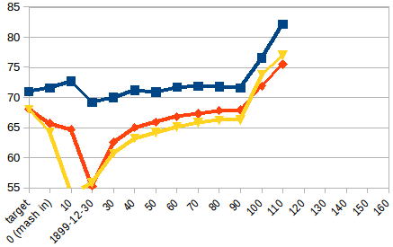
Start Time: 7am
Fill mash tun: wed
Fill sparge kettle: Wed
Fire burners: 7am
Heat Mash Tun : Target Temp: 155
Heat Sparge Kettle: Target Temp: 160
Target Temp (Mash): 154
Grind grain: 8:30am
sparge temp: 71.6
Strike Temp: 68
pump temp: 68
Temp: 65.7
Mash: Duration: 90 minutes
Start: 8:45 Finish: 10:30am
Heat (to deactivate enzymes)
Target Temp: 75.5
Start: 10:30am
Finish:11am
Heat Sparge H20 (Target79.4◦)
Sparge:
Start: 11:10am
Finish: 11:50am
Wort collected: full kettle
Boil : Burner On: 11:07or so
Rolling Boil: 12:15
Hops In: 1:00
Hops In: 1:50
Hops In: 1:59
Duration: 90 min
Start: 12:30
Finish: 2pm
Burner Off: 2 pm
Rest 15 min
Start: 2:15
Finish: pm
OG : 1.068-69 (before berry addition)
Yeast:Mauri brew Yeast
Irish Moss: 1 tablet
Notes:
no false bottom in mash tun/ no re-circ/ empty mash tun and clean all lines/ re-fill and start again at 9:30
cook blackberries to +84c and chill pot in sink

